7.1.1 LEAP YEAR
ALGORITHM
Step 1: Start
Step 2: Input integer n
Step 3: If n ≤ 0
Print "Invalid Input" and Stop
Step 4: Set i ← n
Step 5: While i ≥ 1
Set j ← 1
While j ≤ i
Print "*" (without space)
j ← j + 1
Move to next line
i ← i − 1
Step 6: Stop
FLOWCHART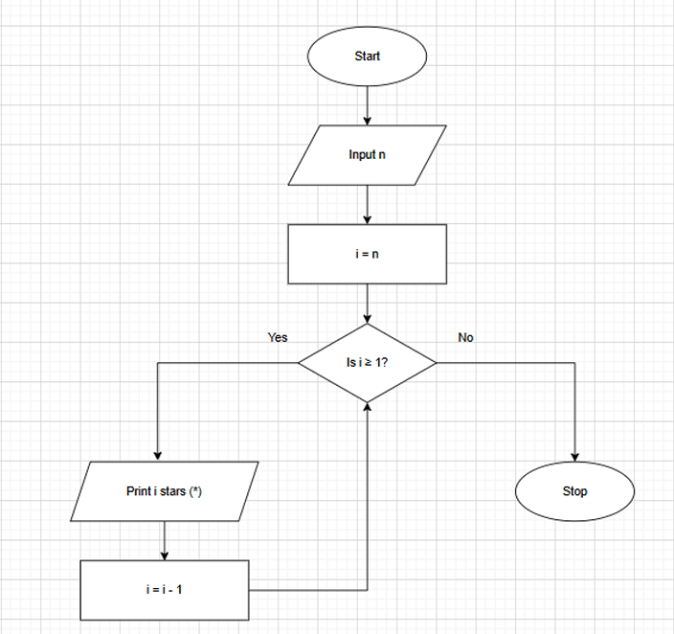

PROGRAM
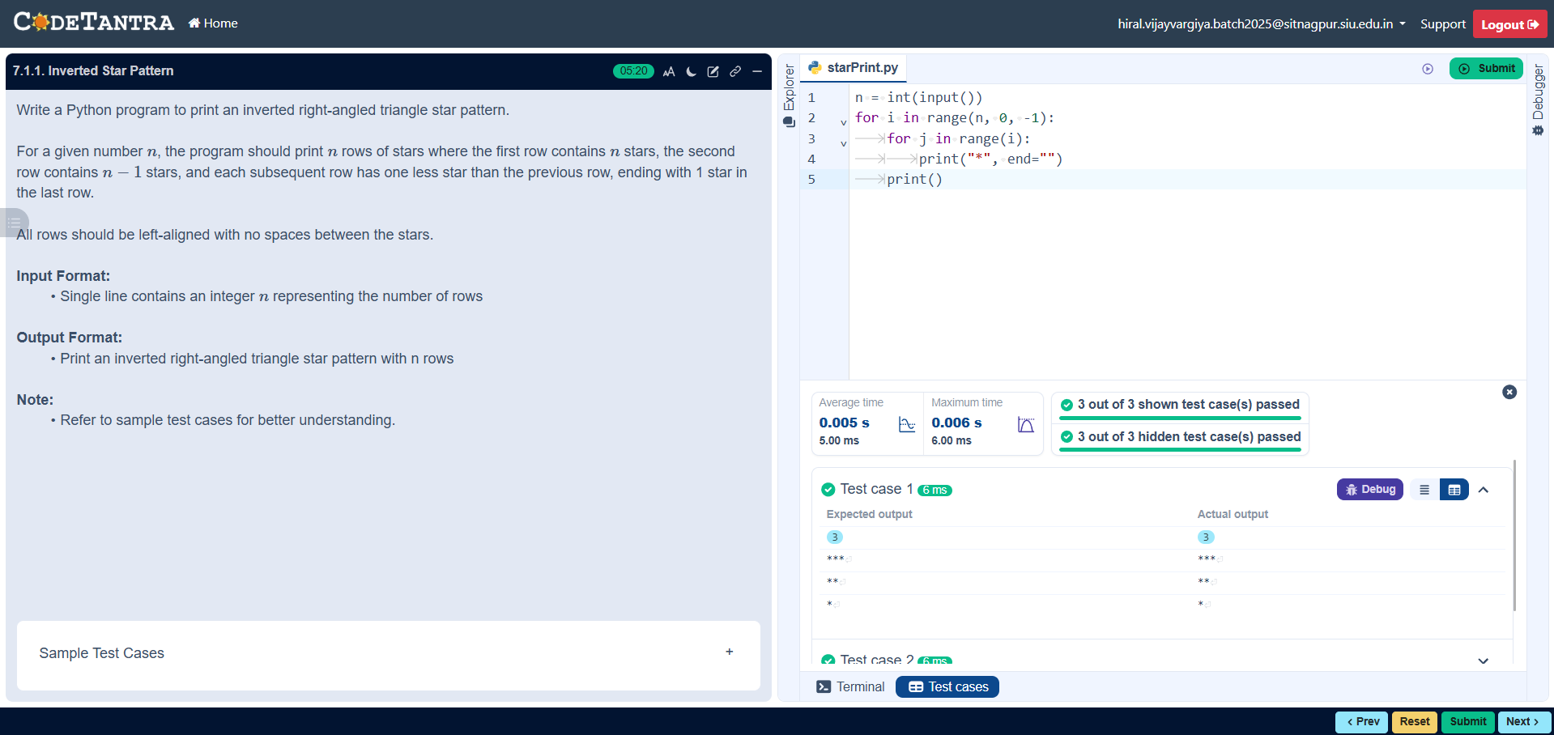

7.1.2 POSSIBLE COMBINATIONS FROM THREE DIGITS
ALGORITHM
- Start
- Input three digits a, b, c
- Store them in a list digits = [a, b, c]
- For i from 0 to 2
For j from 0 to 2
For k from 0 to 2
If i ≠ j AND j ≠ k AND i ≠ k
Print digits[i] digits[j] digits[k]
- Stop
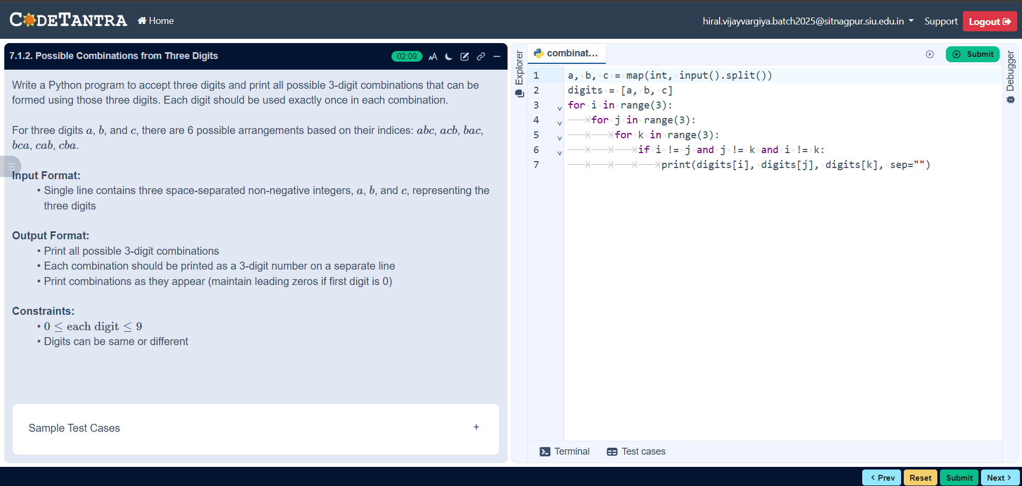
PROGRAM

FLOWCHART
